LAB-8

ESE-3014

SUBMITTED BY

AMANDEEP KAUR(748434)

SHWETA GULATI(747925)

**Part 1**

In this , a program is written in editor window, in which a message is encrypted using public key(RSA) and after that the message is decrypted by using a private key (RSA).

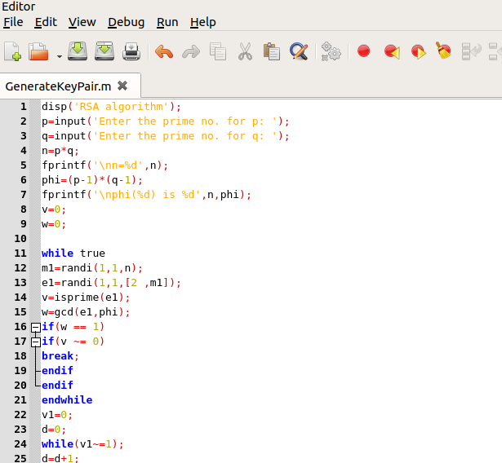

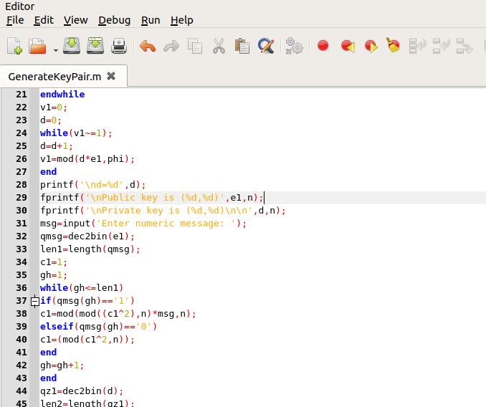

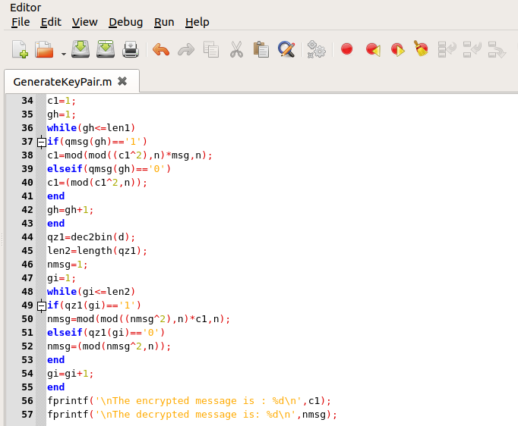

Results:

The program is then run in command window and screenshot of the result is taken.

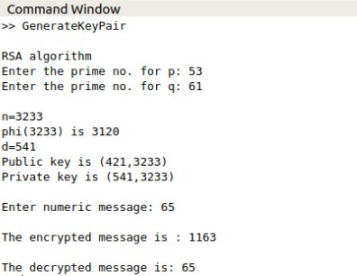

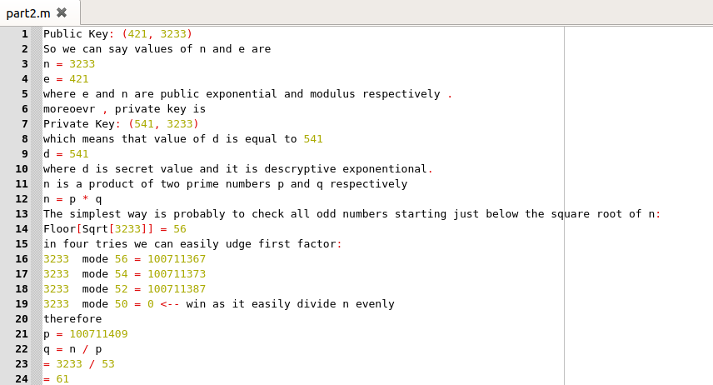**Part 2 of Lab 8**

